# Problems I want to solve

* Things that are meant to help children with autism are typically expensive/inaccessible to people in the lower to middle class.
* Many models of treatment are for toddlers and not older children
* Some treatments teach children to mask, which is bad for the child’s mental health.
* There is a larger focus on improving communication skills instead of managing or understanding other potential problems that come with being autistic.

# Scope

Target Demographic: Children ages 8 to 12 with high-functioning autism, sensory processing sensitivity, and/or problems communicating who are part of the upper-lower to middle class.

High functioning autism: No intellectual disability, able to function independently however may struggle to develop socialization skills and other stuff.

Downloadable Computer Program that helps develop social skills and coping strategies.

Program has Four Segments.

1. Socializing - AI helps teach child communication skills.
   1. Can chat with AI without judgment
   2. Can select a social problem and the AI will help teach skills to handle the problem.
   3. Teach the AI all about special interest.
   4. Play games
2. Emotional regulation
   1. Games that help develop mindfulness skills
      1. Grounding game
      2. Relaxing game
   2. AI teaches different skills
      1. Breathing techniques
      2. Grounding techniques
      3. How to check in with yourself
3. Sensory Processing Help - Dealing with sensory problems and how to manage it.
   1. Sight
   2. Sound
   3. Smell
   4. Taste
   5. Touch
4. Alternatives Finder - Find alternatives for items or foods, would be a large database. This would be a searchable database, with results personalized to the child.

Working name: Pat.

# Disadvantages over Robots

It lacks physicality, which is helpful in forming a bond (which is important for getting the kid to be comfortable around the AI).

However, robots are costly and downloadable programs are more affordable. Even with all the things I want this to do.

# Development

Because some of the features in my plan are a bit advanced, I would probably isolate them into parts within the development process ordered by what is considered important. I would rather it be amazing with only one thing than barely working at all.

First: Can select a social problem and the AI will help teach skills to handle the problem.

[Social Problem Help](https://docs.google.com/document/d/1LGbHLGc6rF_lgME2bWW_4u-W4ehFuLRlGVdofZ9T5Ug/edit)

Second: Play Social Development games

Third: Sensory Help

Fourth: Games that help develop mindfulness skills

Fifth: Alternatives Finder

Sixth: Ai teaches different skills

Seventh: Teach AI about Special Interest

Eight: Have conversation with AI

# User Interaction

# Socializing

## Chatting with the AI

Chatting comes in the form of talking into a headset or to the computer, or chatting via text.

Things I have yet to figure out: Will the AI be able to understand verbal communication? Verbal is more advanced than I am able to figure out.

## Model

The AI will have a cartoon-like model (something probably in 2D) and a voice like Siri or Alexa that the user can teach pronunciation of nouns (so it says your name right).

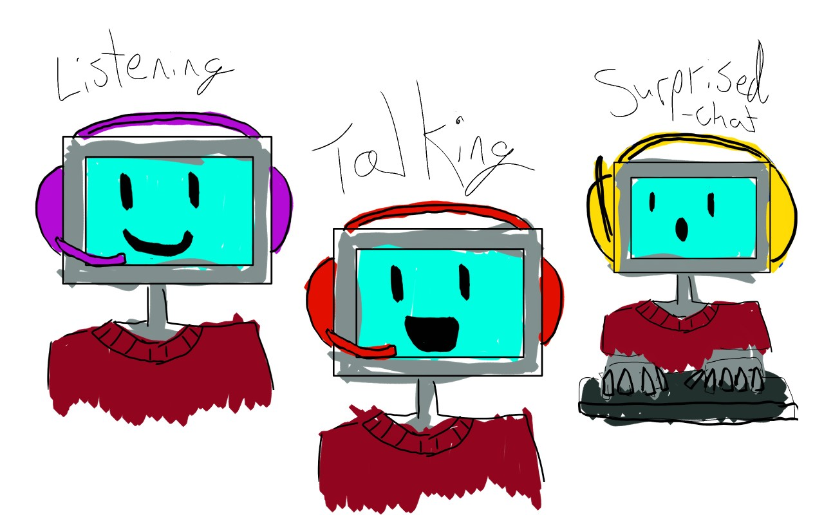

This is my first concept sketch of what I am picturing.

An open mouth when the model is speaking, closed when not. A keyboard with hands typing when chatting with the microphone of the headset up.

I like the idea of the model wearing a simple t-shirt and a color-changing headset that matches the emotion it is expressing.

One thing I would like to change is what the model is. In the concept it is this anthropomorphic computer, which does not have the appearance I want.

The model needs to be something that is visually appealing to older children and this anthropomorphic computer does not cut it. It looks too much like something you would see in school when with a program that teaches you to type.